* In the Java perspective right-click the project name in the Package Explorer window.
* In the pop-up menu choose Properties
* On the left  list of the new window choose Java Build Path
* On the right part of the window choose the Libraries
* Click the Add External JARs button
* In the file chooser search and find the jar file with the oracle drivers you downloaded
* Click Open to add it to Libraries.

**Schema:**

DROP TABLE EMPDETAILS;

DROP TABLE EMPSAL;

CREATE TABLE EMPDETAILS(EMPNO INT,FNAME VARCHAR2(20),LNAME VARCHAR2(20),POSITION VARCHAR2(20),ADDRESS VARCHAR2(30),

CONSTRAINT PKEMPDETAILS PRIMARY KEY (EMPNO));

CREATE TABLE EMPSAL(EMPNO INT,ENAME VARCHAR2(20),SAL INT,POSITION VARCHAR2(20),

CONSTRAINT PKEMPSAL PRIMARY KEY (EMPNO),

CHECK (sal between 2000 and 5000));

**CODE:**

package programming;

import java.sql.*;

public class Database {

public static void main(String[] args) {

Connection conn = null;

Statement stmt = null;

try{

Class.forName("oracle.jdbc.driver.OracleDriver");

conn = DriverManager.getConnection("jdbc:oracle:thin:@db.csep.umflint.edu:1521:csep","rnadavat","rnadavat");

stmt = conn.createStatement();

conn.setAutoCommit(false);

String fname = " 'SMITH',";

String lname = "'JOHNSON',";

int empno = 209;

String address = "'Mumbai',";

try{

System.out.println("Inserting rows into empdetails table and empsal table");

String sql1 = "insert into empdetails(fname,lname,address,empno) values(" + fname + lname + address + + empno + ")" ;

String sql2 = "insert into empsal(Ename,empno) values(" + fname + empno + ")" ;

stmt.executeUpdate(sql1);

stmt.executeUpdate(sql2);

//conn.commit();

System.out.println("successfully inserted");

}

catch(SQLException e1){

System.out.println(e1);

System.out.println("Roll back performed");

conn.rollback();

}

try{

String position = "'Software Developer'";

int sal = 4900;

System.out.println("Updating the empdetails table and empsal table");

String sql4 = "update empdetails set position = " + position + "where empno = " + empno;

stmt.executeUpdate(sql4);

String sql5 = "update empsal set position = " + position + "where empno = " + empno;

stmt.executeUpdate(sql5);

String sql6 = "update empsal set sal = " + sal + "where empno = " + empno;

stmt.executeUpdate(sql6);

conn.commit();

System.out.println("Statements all updated and inserted");

System.out.println("STEP:2 worked successfully");

}catch(SQLException e){

conn.rollback();

System.out.println(e);

System.out.println("If the one of the above insert or update command fails then ROLLBACK");

System.out.println("STEP:3 worked successfully");

}

String sql3;

System.out.println("Displaying multiple rows");

sql3 = "select * from empdetails order by empno";

ResultSet rs = stmt.executeQuery(sql3);

while(rs.next()){

System.out.println("emp no =" + rs.getInt("empno") + "\t" + "First name=" + rs.getString("fname") +

"\t" +"last name =" + rs.getString("lname") + "\t" +"Position =" + rs.getString("position")+ "\t"

+ "Address =" + rs.getString("address"));

}

System.out.println("STEP:1 Worked successfully");

rs.close();

stmt.close();

conn.close();

}

catch(SQLException e2){

e2.printStackTrace();

}

catch(Exception e2){

e2.printStackTrace();

}

finally{

try{

if(stmt!=null)

stmt.close();

}catch(SQLException e3){

}

try{

if(conn!=null)

conn.close();

}catch(SQLException e4){

e4.printStackTrace();

}

}

}

}

Output: For Step 1 and 2

Multiple records:

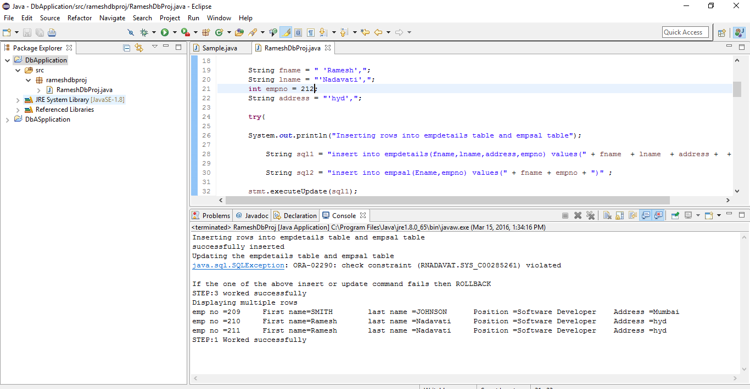

Output for Rollback:



**Some of helpful links to download software:**

1. Java

http://www.oracle.com/technetwork/java/javase/downloads/jdk7-downloads-1880260.html

1. Oracle

<http://www.oracle.com/technetwork/developer-tools/sql-developer/downloads/index.html>

1. OJDBC

http://www.oracle.com/technetwork/database/enterprise-edition/jdbc-111060-084321.html